**Article Title**

***Author1, Author2, and Author 3***

*Organization, http://www.organizationlink.xx*

**Abstract**: .

**Keywords**: .

### Introduction

Authors, include your 16-digit ORCID id/numbers in your CV at the end of the manuscript. If you do not have one, we highly recommend to register at https://orcid.org/.

In the last paragraph outlines the structure of the article.

### First Section Title

Citations longer than three lines of text should be placed in a block quote. An example follows. As Robert Horvath notes:

In Narochnitskaya’s narrative, Russia’s mortal enemies in the modern era were the “Anglo-Saxons,” the English-speaking Atlantic democracies. What made the Anglo-Saxons so dangerous was their Puritan, Calvinist heritage, a heresy (*apostasiya*) that perverted their moral sensibility and guided their conduct on the world stage.[1]

In referencing the sources, use footnotes and follow The Chicago Manual of Style for Notes. Examples for the main types of sources are available at [www.chicagomanualofstyle.org/tools_citationguide/citation-guide-1.html](http://www.chicagomanualofstyle.org/tools_citationguide/citation-guide-1.html).

This is an example of a book reference.[2] When you refer to a journal article,[3],[4] a book chapter,[5] or a paper in conference proceedings,[6] include the DOI link instead of the URL of the source. See examples in the footnotes below.

### Second Section Title

### Third Section Title

#### Sub-section Title

#### Sub-section Title

#### Sub-section Title

### Fourth Section Title

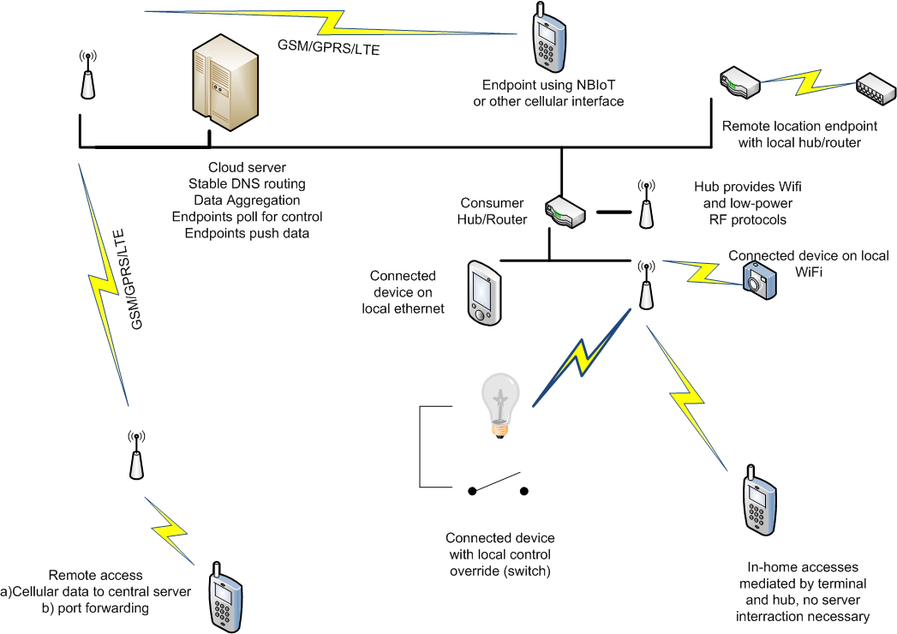

**Figure 1: Chart or Image of Print Quality.**

**Table 1. IoT Diffusion by Sector in Billions of Devices (2015–2020).**

|  |  |  |  |
| --- | --- | --- | --- |
| Category | 2015 | 2020 | Percent Increase |
| Automotive | 372 | 3511 | 944 % |
| Consumer | 2,875 | 13,173 | 458 % |
| Generic business | 624 | 5,159 | 827 % |
| Vertical business | 1,009 | 3,164 | 314 % |
| Total | **4,880** | **25,007** | **512 %** |

Source: Gartner, “4.9 Billion Connected ‘Things’ will be in use in 2015, November 2014.

#### Sub-section Title

#### Sub-section Title

#### Sub-section Title

#### Sub-section Title

#### Sub-section Title

#### Sub-section Title

### About the Authors

**Author names** is …. [5 to 8 lines of text]

*E-mail*: *names@website.org; https:orcid.org/number…*

**Author names** is ….

*E-mail*: *names@website.org; https:orcid.org/number…*

**Author names** is ….

*E-mail*: *names@website.org; https:orcid.org/number…*

### Bibliography

1. Robert Horvath, “The Reinvention of ‘Traditional Values’: Nataliya Narochnitskaya and Russia’s Assault on Universal Human Rights,” *Europe-Asia Studies* 68, no. 5 (2016): 868-892, <https://doi.org/10.1080/09668136.2016.1184230>.
2. James Wither and Sam Mullins, eds., *Combating Transnational Terrorism* (Sofia: Procon, 2016).
3. Iryna Lysychkina and Olha Lysychkina, “Women, Peace, and Security Dimensions of the War in Ukraine,” *Connections: The Quarterly Journal* 22, no. 2 (2023): 43-56, https://doi.org/10.11610/Connections.22.2.52.
4. Boyan Mitrakiev and Noncho Dimitrov, “Russian Reflexive Control Campaigns Targeting Political Realignment of Ukraine’s Democratic Allies: Critical Review and Conceptualization,” *Information & Security: An International Journal* 55, no. 3 (2024): 299-330, https://doi.org/10.11610/isij.5519.
5. Todor Tagarev, Gerassimos A. Papadopoulos, Michael Hagenlocher, Richard Sliuzas, Mikio Ishiwatari, and Eduardo Gallego, “Integrating the Risk Management Cycle,” in *Science for Disaster Risk Management 2020: Acting Today, Protecting Tomorrow*, ed. Ainara Casajus Valles, Monserrat Marin Ferrer, Karmen Poljanšek, and Ian Clark (Luxembourg: Publications Office of the European Union, 2020), 49-106, https://doi.org/10.2760/571085.
6. Todor Tagarev, “Governance of Collaborative Networked Organisations: Stake­holder Requirements,” *Proceedings of the 11th IEEE International Conference on Dependable Systems, Services and Technologies*, DESSERT 2020, Kyiv, Ukraine, May 14-18, 2020, 439-445, https://doi.org/10.1109/dessert50317.2020.9125029